

Name of the Organization: ______________________________________________________________________________

Address: ____________________________________________________________________________________________

____________________________________________________________________________________________________

Telephone No: ____________________________________ Mobile: ___________________________________________

Email: ______________________________________________________________________________________________

Nature of Business : ___________________________________________________________________________________

PAN No.: _____________________________________ GST No: ______________________________________________

Details of Delegates:

|  |  |  |  |  |  |
| --- | --- | --- | --- | --- | --- |
| **Name** | **Passport No.** | **Date of Issue** | **Date of Expiry** | **Insurance** | **Nights** |
|  |  |  |  |  |  |
|  |  |  |  |  |  |
|  |  |  |  |  |  |
|  |  |  |  |  |  |
|  |  |  |  |  |  |

(Use extra sheet if need be)

Room Category: Twin Sharing Single Member of AIPMA: Yes No

Package Preference: Phase Nights

Meal Indian : Jain Veg Non-Veg

Insurance : (a) Yes No (b) Date of Birth: ______________________________________

Port of Departure: Mumbai Delhi Chennai Kolkata

Ahmedabad Kochi Hyderabad Bangalore

Payment by Cheque / Draft No. / UTR No: __________________________________ Date: ___________________________

Bank : ____________________________________________________ Branch : ___________________________________

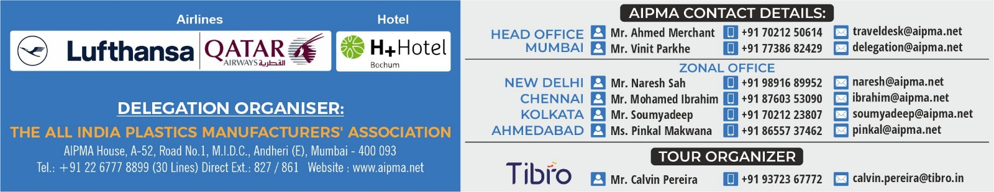Amount Rs. __________________________________________________________________________________________